Fractional General Counsel Page Structure

Understanding Fractional General Counsel | The Engagement Model | How We Work | Our Capabilities | Who We Support | Our Approach

Internal Submenu format
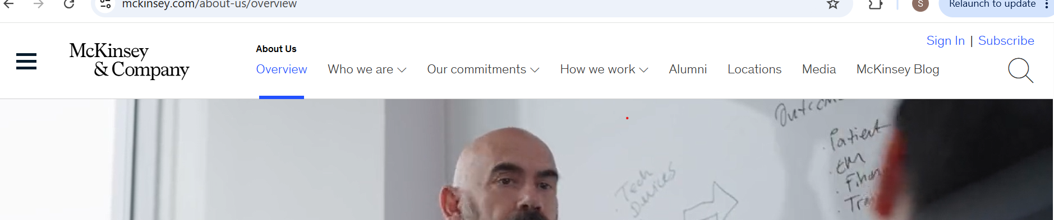

Sub-menu Format:
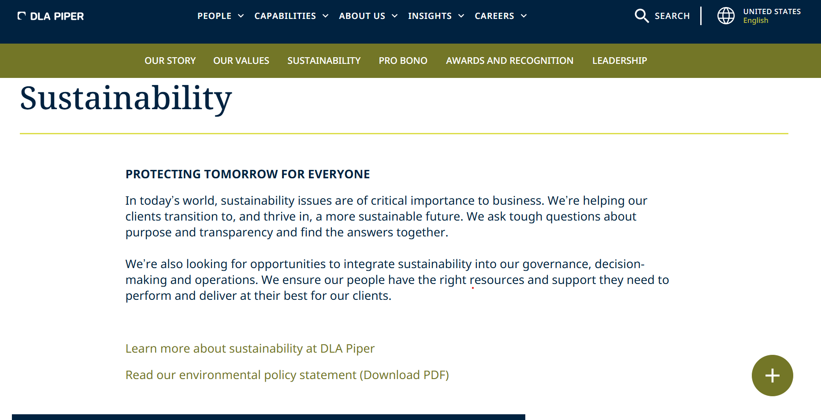

Fractional General Counsel – Page

Fractional General Counsel Services/ What Is Fractional General Counsel?
Ongoing Legal Support That is Flexible by Design
A Fractional General Counsel provides businesses with ongoing access to experienced legal leadership through a flexible engagement model. Instead of seeking legal support only when specific issues arise, businesses benefit from a continuing legal relationship that remains connected to their operations, priorities, and changing requirements.
The engagement is tailored to the organisation's requirements and can work alongside an existing in-house legal team or provide ongoing legal support where no internal legal function exists. The level and nature of support can adapt as business requirements change, providing flexible access to senior legal expertise without the fixed commitment and overhead associated with a full-time General Counsel function.

Design Reference
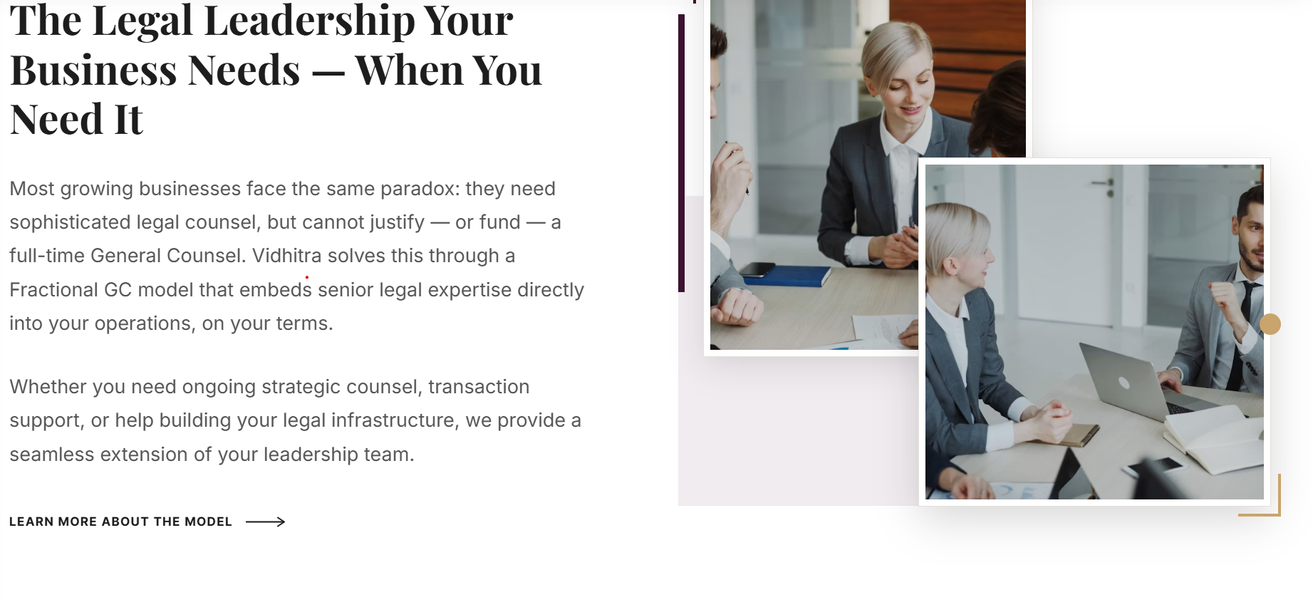
Or
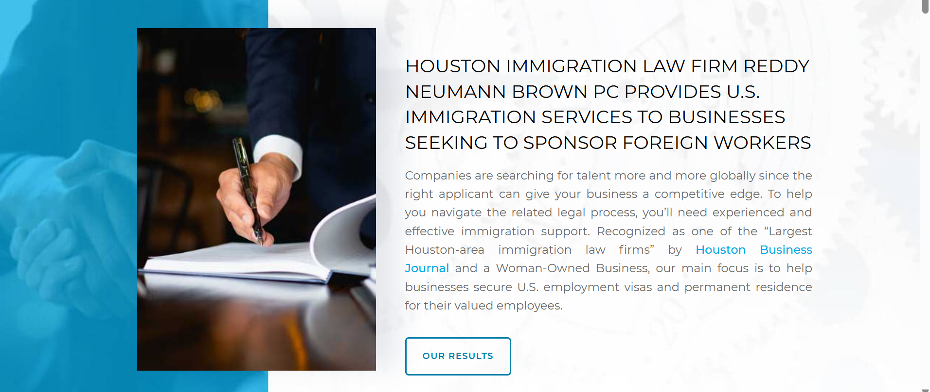

The FGC Model/ Understanding the FGC Mode
Legal Support That Fits the Way Your Business Works
The Fractional General Counsel model is designed to integrate with the way a business already operates. It can provide ongoing legal support where no in-house legal function exists, work alongside an existing legal team, or provide additional senior-level capacity during periods of increased workload, transition, or changing business requirements.
The engagement is tailored to the organisation's needs. The scope of support, level of involvement, and way of working are shaped around the business, allowing legal support to remain aligned with its priorities without the need to establish a full-time General Counsel function.
For the business, this means having a continuing legal resource that is familiar with its operations and available as legal questions, commercial matters, and strategic priorities arise. Instead of treating every legal issue as a separate engagement, the relationship provides continuity, accessibility, and support that develops with the business.

How We Work/ Working Together
A Practical Approach to Ongoing Legal Support
Every business has different legal priorities and ways of working. We begin by understanding where legal support is most relevant to your business and tailor the engagement to provide practical, ongoing support that evolves with your changing requirements.
Our approach typically involves:
Understand
Establishing a clear understanding of your business, its objectives, operations, legal environment, and priorities.
Prioritise
Identifying the matters requiring immediate attention and the areas where continuing legal support can provide the greatest value.
Advise
Providing practical legal guidance informed by the circumstances and objectives of each matter.
Support
Working with business leaders, management teams, in-house legal teams, external law firms, and other stakeholders to help address legal matters and implement decisions.
Adapt
Adjusting the nature and level of support as your priorities, resources, and requirements evolve.

Design reference: the heading written on pictures and animated

https://www.mckinsey.com/capabilities/business-building/how-we-help-clients
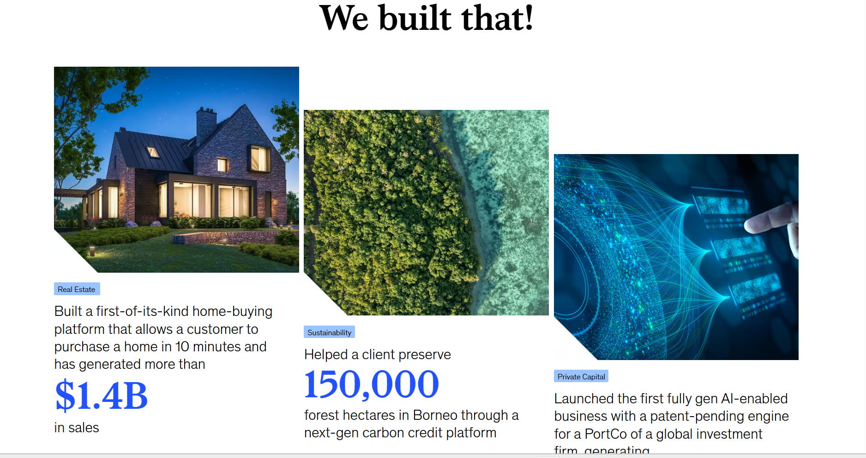



Expertise/ Legal Support Across Your Business
Legal Support Across the Business
Fractional General Counsel support can extend across the legal and commercial issues that arise as a business is established, operates, grows, and evolves.
CORPORATE & STRATEGIC BUSINESS MATTERS
Structure • Governance • Transactions
COMMERCIAL CONTRACTS & BUSINESS RELATIONSHIPS
Contracts • Negotiation • Commercial Relationships
INFRASTRUCTURE, PROJECTS & BIDS
Procurement • Projects • Bids
REGULATORY COMPLIANCE & BUSINESS RISK
Governance • Compliance • Risk
TECHNOLOGY, IT & DIGITAL BUSINESS
Technology • Data • Digital Business
EMPLOYMENT & WORKFORCE MATTERS
Workforce • Workplace • Organisational Change
MARKET ENTRY, STARTUPS & EMERGING BUSINESSES
Establishment • Expansion • Growth

Design reference – list the capabilities and link it with Capabilities Page
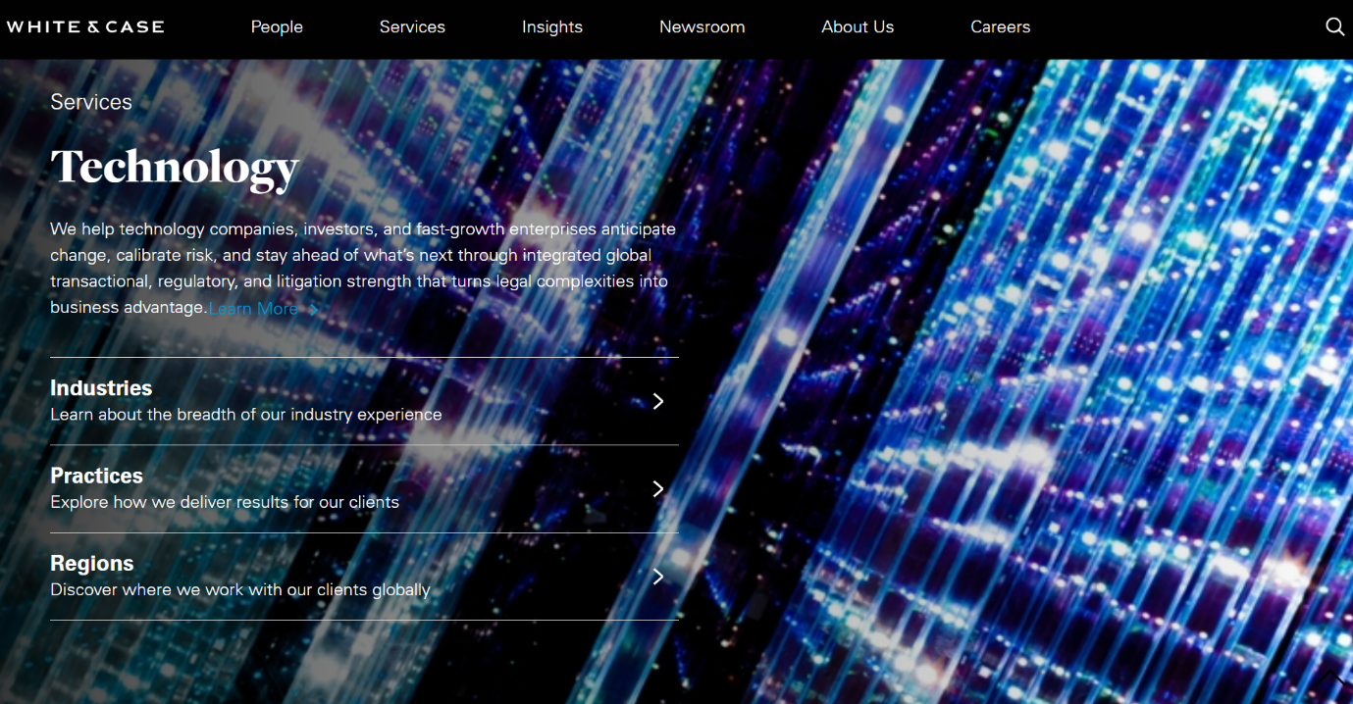

Who This Model Is Designed For/ Who Is It Designed For?
The Fractional General Counsel model can be relevant to businesses at different stages of development and with different legal support structures.
Target Clients
- Founders & Entrepreneurs
- Startups & Emerging Businesses
- SMEs & Growth-Stage Businesses
- Established Private Companies
- Family-Owned Businesses
- Project-Driven Organisations
- Technology & Digital Businesses
- International Businesses Entering or Operating in India
- In-House Legal Teams Requiring Additional Capacity or Senior-Level Support

Design reference

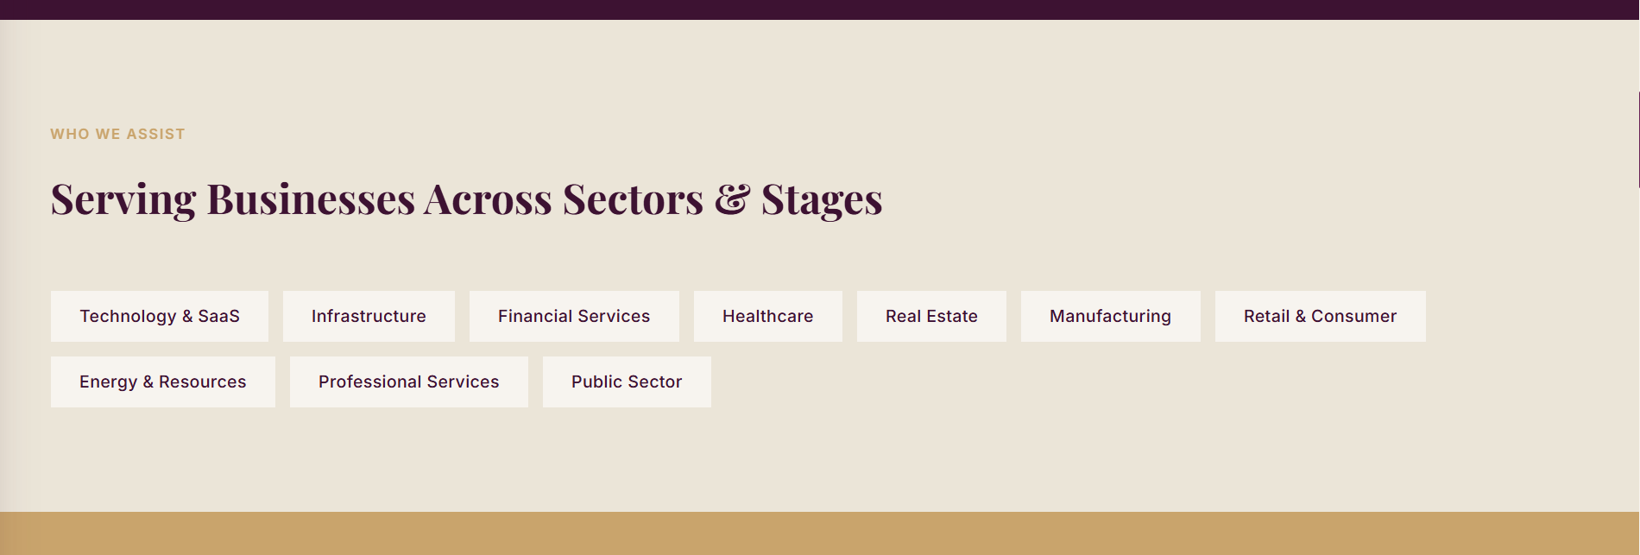

Why Continuity Matters
Legal Advice That Helps Businesses Grow
One of the greatest advantages of a Fractional General Counsel is continuity. As the legal relationship develops, less time is spent explaining the business, its background, and previous decisions. Instead, legal support builds on an understanding of the organisation, its priorities, and the way it operates.
This enables legal support that is more consistent, responsive, and aligned with the business. Whether addressing day-to-day legal matters, supporting significant business decisions, or responding to changing legal requirements, advice is provided with the benefit of an ongoing understanding of the organisation.
As the business grows, the engagement evolves with it. A Fractional General Counsel can continue to provide strategic legal leadership, work alongside and strengthen an existing in-house legal team, or support the development of internal legal capability as per the changing requirement of the organisation. The value lies in building a trusted legal relationship that continues to support the business through each stage of its growth.

Design to be suggested

